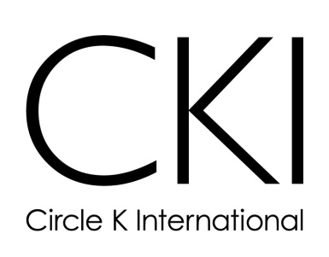

Membership Retention
Phone Calls:
Description:
Calling new members before the next meeting is a good way to ensure their return. Personal calls can make people feel more welcome and they can be a great reminder of the upcoming meeting.
Involvement Needed:
This will of course depend on how many new members you have however you should have a minimum of two people to do the phone calls. Make it easy and write a script; be sure to keep it casual though!

Surveys:
Description:
Surveying your members is a great way to find out the sort of service projects that they are interested in. Finding service projects and events that suit your members’ interests is a great way to keep them coming.
Involvement Needed:
You should only need one or two volunteers to complete this.

Retreats:
Description:
Holding retreats and socials for your members is an excellent way to increase friendships within your club. These can be parties held at a member’s home or outings, such as laser tag, canoeing, or rock climbing.
Contact Information:
You can contact local restaurants to donate food for socials. If you’re going on a retreat you can contact an outdoor events group and see what they have to offer.
Involvement Needed:
The planning for this will take one or two people.

Service:
Description:
It is a good idea to have service projects planned in time for your activities fair or first club meeting. This way members can sign up for something right away and get involved from the start.
Involvement Needed:
Only one person is needed to set up the project. If your club has a Vice President of Service it would be their job to do so.

Spotlight:
Description:
Everyone likes to feel appreciated or hear a thank you once in a while. Your club should spotlight a member at each meeting or once a month. You could give them Circle K paraphernalia (a cup or a pencil), candy, coupons, or certificates. This person should also be mentioned in the club newsletter.
Contact Information:
You may need to ask the officer who keeps track of volunteer hours which member has been the most active, in order to decide who should receive the award.
Involvement Needed:
The entire board should vote on who will be spotlighted each month.

Call Out:
Description:
All club members should sit in a circle with the club officers in the center. The officers will then discuss what Circle K is about and what is special about their particular club. The faculty and Kiwanis advisor should also be present for the question and answer period.
Involvement Needed:
All officers and advisors should be in attendance.

Board Positions:
Description:
People typically feel more important when they have a role. Giving members, in whom you see potential, committee positions to run is a great way to ensure that they will become more involved in the future.

CKI 101
Description:
This is a way to teach the club more about Circle K. This can be done through trivia games, Jeopardy, handouts, and group activities.
Contact Information:
You may need to go to the Circle K website or contact the International Office for more information and facts for your game. Also try your District Membership Development and Education Committee Chair (mde@cdcki.org).
Involvement Needed:
One person can plan the game by the entire club should participate.

Buddy System:
Description:
Each new member should be paired up with an old member. The old member is then in charge of calling the new member to remind them of meetings and events. The two can also go to service projects together. The club can even hold buddy socials. This system can also be done with members and Kiwanians.

